Ecole Doctorale
Sciences de la Terre et de l’Environnement

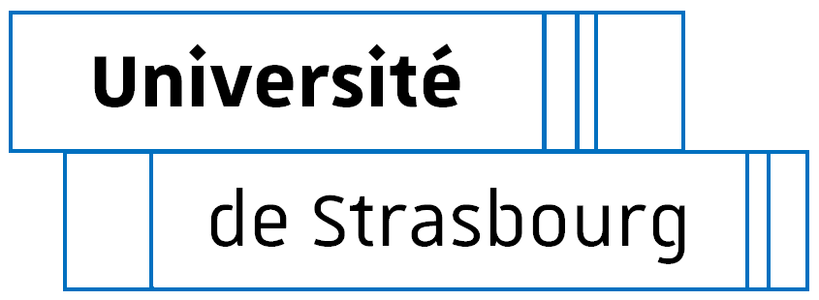

APPLICATION FOR A DOCTORAL CONTRACT – YEAR 2024
To be filled out on a computer if possible

CANDIDATE
Mr or Ms (check)
FAMILY NAME (in capital letters):………………………………..………………………………………………..
FIRST NAME (in capital letters): …………………........................................................................................
E-mail address (required): ..........................................................@...........................................................
Phone : ..................................................................................................................................................
Address : ........................................................................................................................................................
Zip code : ............................ City : .......................................................... Country : .....................................
Birth date (day/month/year) : |___|___| |___|___| |___|___|___|___|
Place of Birth: …………………..…………………….. Department or Country: ………………………..............
EDUCATION
Starting with undergraduate degree or its equivalent

Year | University or School  where degree was/is being prepared | Grades  & ranking
20….-…..
20….-…..
20….-…..
Master - S1
20….-…..
Master - S 2
20….-…..
Master - S 3
20….-…..
Master - S 4
20….-…..
(eventually)
Date at which your grades will be available for the fourth semester of your Master’s program:

Candidate’s family name and first name : ………………………………….……………………………

I am interested in the following Ph.D. subject :

………………………………………………………………………………………………………………....

I state that I am a candidate for a Ph.D. contract at the Doctoral School STE (ED STE). I am aware of the calendar of the application process displayed on the website of the ED STE concerning the awarding of these Ph.D contracts.
The transcript for the fourth semester of my Master’s must be sent as soon as it is available to finalize the awarding of my doctoral contract.
I have noted that the Doctoral School will communicate with me by e-mail (at the address indicated on page 1) and that I should be reachable by this means until the end of the contract award operations. Finally, if my application passes the first selection stage, I will be auditioned.
The auditions will take place on June 10, 2024, in Strasbourg face-to-face.

Place …………………………., date …………2024 Candidate’s signature :

Each file will consists of two parts :

The candidate documents:

– a curriculum vitae
– a copy of your undergraduate diploma or a certificate stating that you successfully obtained your undergraduate diploma
– a transcript of your grades (from the first session) of the first, second and third semesters of your Master’s program. If you are not in a Master’s program, you should provide transcripts of your grades from your fourth year and the first semester of your fifth year of undergraduate studies. These transcripts must have the university’s stamp. These transcripts should state which courses you followed, your grades for each semester, your ranking and the number of candidates who passed the exam.
– a recommendation letter of your supervisor during your M2 training
– a cover letter of the candidate addressed to the director of the Doctoral School.
– this completed application form.

The supervising team documents (for each director and co-supervisor of the thesis):

– obtained date of the HDR (Habilitation thesis to supervise PhDs),
– research unit name and unit address (only for non-Strasbourg supervisors),
– names of PhD students presently supervised (during the current academic year),
– planned date of thesis defense for each PhD student (please notify the exact day).
– the report of the audition, which led to the choice of the candidate.

The candidate will send the complete file with its 2 parts in a single PDF document attached to an email addressed to ED STE no later than May 21, 2024 at 12 noon, to:

Mrs Blanche Facchini (dir-ed413-secretariat@unistra.fr) - Ecole Doctorale Science de la Terre de l’Environnement Collège Doctoral - 46 Boulevard de la Victoire – 67000 Strasbourg and copy to the director of the doctoral school, Mr. Damien Lemarchand (lemarcha@unistra.fr).

The thesis director will ensure that the file is complete.

The file will be named as follows: "NameDT_NameDoc.pdf" where NameDT is the name of the thesis director and NameDoc the name of the candidate.

