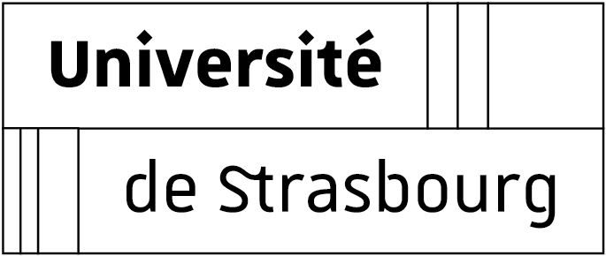

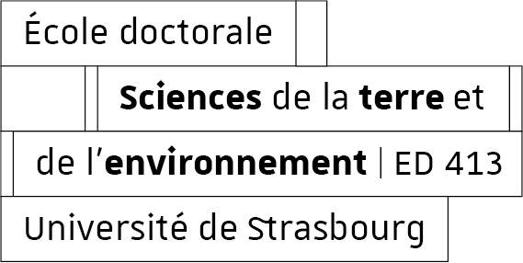

APPLICATION FOR A DOCTORAL CONTRACT – YEAR 2026
To be filled out on a computer if possible

CANDIDATE
Mister ☐ Madam ☐
Family and first name:
Email:
Phone:
Address:
Zip code: City: Country:
Birth date:
Place of birth: Department or Country:
EDUCATION
Starting with undergraduate degree or its equivalent

Year | University or School  where degree was/is being prepared | Grades  & ranking
20….-…..
20….-…..
20….-…..
Master - S1
20….-…..
Master - S 2
20….-…..
Master - S 3
20….-…..
Master - S 4
20….-…..
(éventuellement)
Date at which your grades will be available for the fourth semester of your Master’s program:

I state that I am a candidate for a Ph.D. contract at the Doctoral School STE (ED STE). I am aware of the calendar of the application process displayed on the website of the ED STE concerning the awarding of these Ph.D contracts.
The transcript for the fourth semester of my Master’s must be sent as soon as it is available to finalize the awarding of my doctoral contract.
I have noted that the Doctoral School will communicate with me by e-mail (at the address indicated on page 1) and that I should be reachable by this means until the end of the contract award operations. Finally, if my application passes the first selection stage, I will be auditioned.
The auditions will take place on June 2, 2026, in Strasbourg face-to-face.

Place date

Candidate’s signature:

The supervising team documents, for each director and co-supervisor of the thesis (2 max):

Thesis supervisor 1:

Family and first name of the thesis supervisor:
Obtained date of the HDR :
Research unit name and unit address, for non-Strasbourg supervisors:

Names of PhD students presently supervised (during the current academic year):

Planned date of thesis defense for each PhD student:

Thesis supervisor 2 (if applicable):

Family and first name of the thesis supervisor:
Obtained date of the HDR :
Research unit name and unit address, for non-Strasbourg supervisors:

Names of PhD students presently supervised (during the current academic year):

Planned date of thesis defense for each PhD student:

Contact :
Géraldine Schverer (dir-ed413-secretariat@unistra.fr)
Ecole Doctorale Science de la Terre de l’Environnement
Collège Doctoral
46 Boulevard de la Victoire
67000 Strasbourg

